1.46:

1.47:

A1-1.46

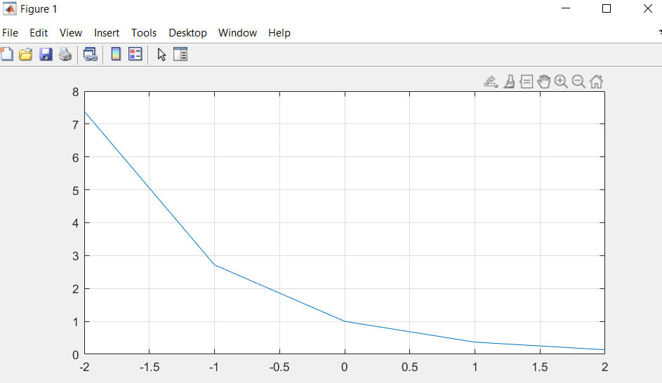

A2

The graphs are very similar, in fact they are identical, as cos(2*pi*t) is one for all integer values in the range t = [-2:2] meaning at these points the graph at A1-1.46 is f(t) = e-t *(1) which is the same function for A2 f(t) = e-t thus both functions resulted in the same graph for integer values in the range t = [-2:2].

Both graphs were manipulated by similar factors (expanded by a factor of 2 on x axis and shifted by a ½ and ¼ to the right respectively ) however n2 was expanded then shifted while n4 was shifted then expanded. This resulted in 2 different transformations. The starting point of n2 is at (-0.5, 0) but that of n4 is (-1,0). The peak of n2 is at (1.5, 1) but that of n4 is (2, 0.75). n4 does not have the whole graph in the range of t = [-2 : 2] (not even half) while the graph of n2 has more than half the graph in that range. This concludes that order of transformations on a graph affect the final result.



Using a loop:



S1 [0 : 0:01 : 4]

S3 [0 : 0:01 : 4]



S5 [0 : 0:01 : 4]

S7 [0 : 0:01 : 4]

4x 401 = 1604

1. A( : ) returns all the values in the matrix in order
2. A([ 2 4 7 ]) returns the values at position 2 4 7
3. [ A >= 0.2 ] returns a 5 x 4 matrix with 1 (true) in each cell that has a value greater than or equal to 0.2 and 0 (false) in each cell that doesn’t
4. A([ A >= 0.2 ]) returns the number in the matrix with values greater than or equal to 0.2 in order
5. A([ A >= 0.2 ])=0 returns matrix A but with all values greater than or equal to 0.2 set to 0

Order in a matrix:

|  |  |  |  |
| --- | --- | --- | --- |
| 1st | 6th | 11th | 16th |
| 2nd | 7th | 12th | 17th |
| 3rd | 8th | 13th | 18th |
| 4th | 9th | 14th | 19th |
| 5th | 10th | 15th | 20th |

Outcome:

a)

b)



c)

The single line command was 426.7% faster than the nested loop.

